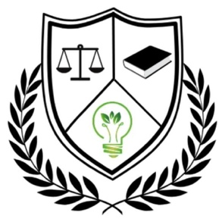
Mammen, R.R. (Rhea)

Report

Report of the MoU

VVI and GLC signed the MoU on 13th December 2024 at the Government Law College campus. We were graced with the presence of Venu Rajamony, Former Ambassador of India to the Netherlands, to inaugurate the initiative. The occasion also saw the establishment of the Indo-Dutch Research Centre for Climate Change Education and Research. The MoU focused on the following engagements, with a focus area on “Law Schools’ Response to Climate Change Education.” The MoU also supported the establishment of the Centre.

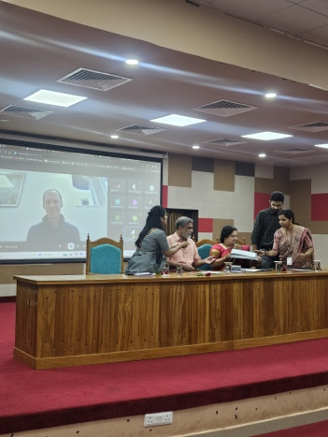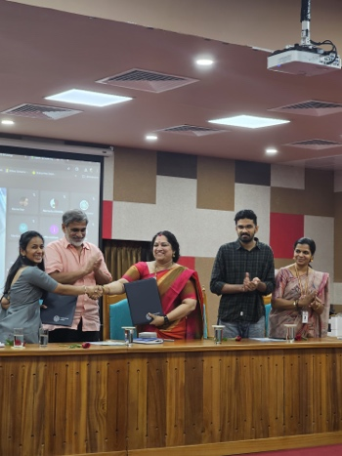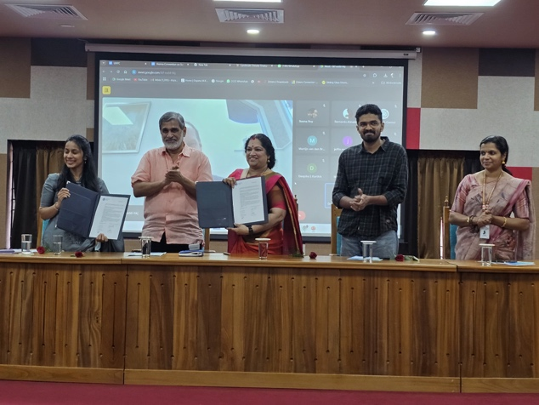
As part of the MoU, the following activities were conducted:
1. Certificate Course on Interdisciplinary Approach
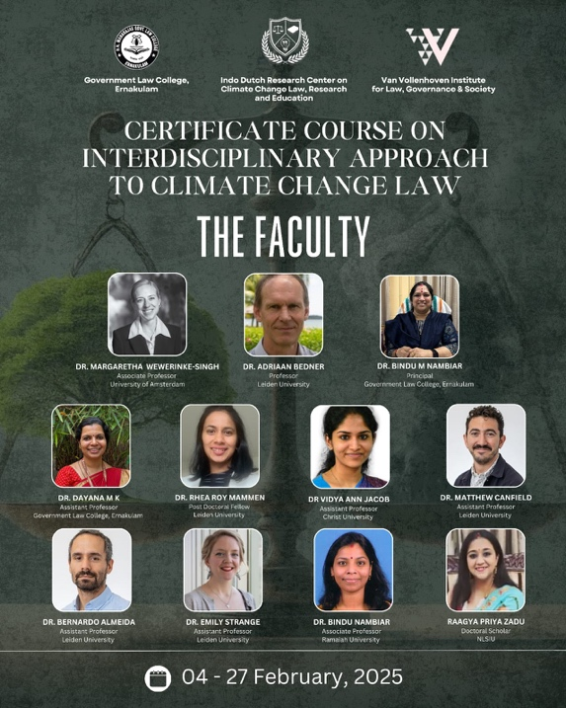
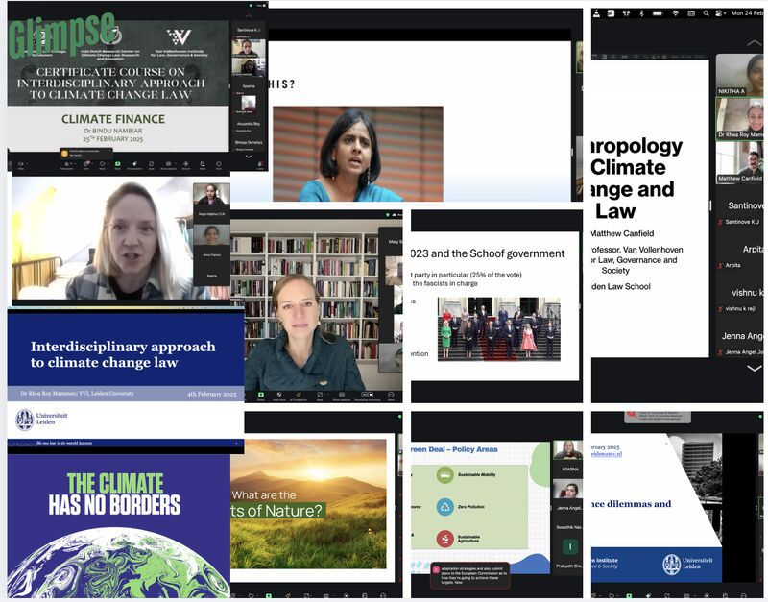
The certificate course was offered to students of Government Law College of Ernakulam by the Van Vollenhoven Institute. The course was delivered by a faculty team from the Netherlands and India. The idea was to expose law students to other disciplines and to the diversity involved in understanding climate change. The course was designed to introduce students to the complexities of climate change laws beyond legal silos, encouraging them to engage with the broader scientific, anthropological, socio-economic, and financial dimensions of climate governance. Over three weeks, students attended 12 interactive sessions led by Margaretha Wewerinke-Singh, Dr. Emily Stranger, Dr. Vidya Ann Jacob, Prof. Adriaan Bedner, Ms. Dhanya Puthucode Krishnan, Dr. Lisa Harms, Prof. Dr. Giri Sankar S. S., Prof. Dr. Matthew Canfield, Raagya, Prof. Dr. Bernardo Almeida, and Prof. Dr. Bindhu Nambiar, alongside me. Topics ranged across climate litigation, biodiversity, legal frameworks, geopolitical divides, EU climate policies, socio-legal perspectives, constitutional rights, anthropology, renewable energy, land rights, and climate finance. This experimental and interdisciplinary initiative underscored the importance of holistic, climate-conscious legal education, pushing students to think critically beyond traditional legal boundaries.
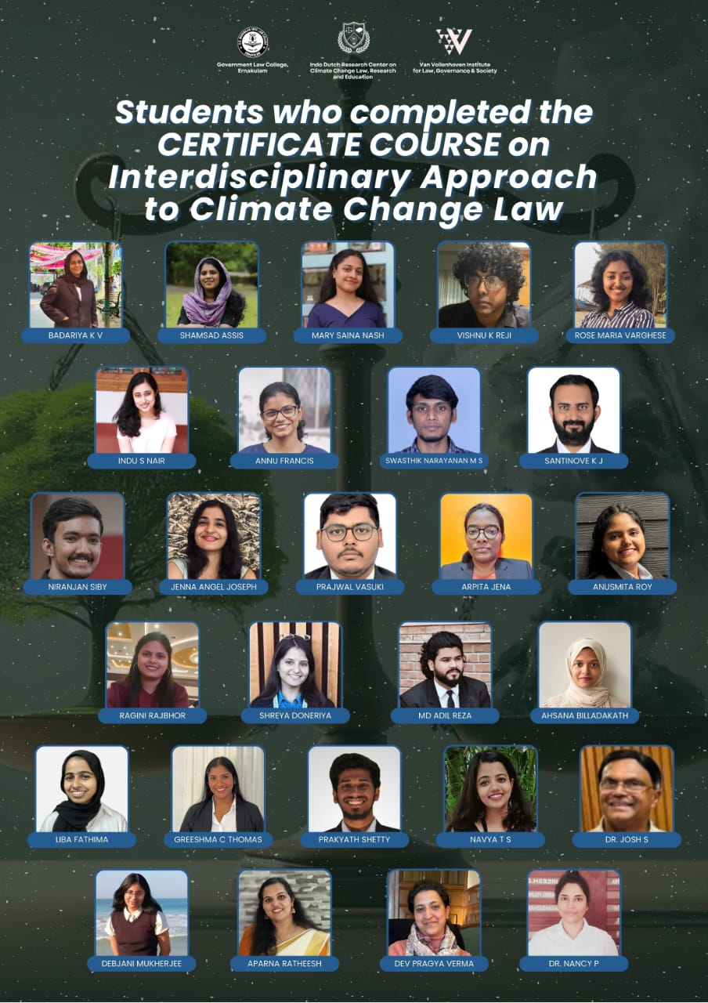

2. International Workshop
Report on the International Workshop on Interdisciplinary Approach to Climate Change Education

The International Workshop on Interdisciplinary Approach to Climate Change Education, held on February 27–28, 2025, aimed to foster dialogue on integrating diverse disciplines into the study and governance of climate change. With the growing complexity and urgency of climate-related challenges, the objective was to promote a holistic approach to climate education and policy by connecting legal, scientific, economic, social, and environmental perspectives. The workshop served as a collaborative platform for academicians, legal professionals, researchers, and students to explore innovative frameworks for addressing climate change, grounded in justice, equity, and sustainability.
The first expert panel, titled "Integrated Approach to Climate Change Laws", focused on the multifaceted nature of climate governance. Moderated by Dr. Giri Sankar S. S., the session featured prominent legal scholars and practitioners including Dr. Stellina Jolly, Dr. Sairam Bhat, Dr. Charu Sivaprasad, Adv. Rajat Jariwal, and Adv. Sriram Panchu. Discussions centered on how climate change affects fundamental rights and the importance of legal accountability through frameworks like Extended Producer Responsibility (EPR) and retributive environmental justice. Panelists highlighted landmark case laws, the importance of integrating climate concerns into legal curricula, and the judiciary’s role in recognizing intersectionality and equity in environmental matters. Adv. Sriram Panchu stressed the need for mediation in resolving complex climate disputes involving multiple stakeholders, promoting consensus-driven solutions. Adv. Rajat Jariwal offered insights from courtroom experience, emphasizing the evolving role of Public Interest Litigation (PIL) in advancing environmental justice. Speakers also addressed geopolitical influences like the Ukraine conflict and underscored the necessity of public participation, green technology, and decentralized governance.

A wide range of paper presentations followed, spread across four venues over the two days. The sessions featured research on diverse themes such as greenwashing and consumer deception, weather modification and international law, Arctic maritime pollution, food safety standards under climate stress, climate-induced displacement, ESG disclosures, blue-green infrastructure, and the vulnerability of indigenous communities. Many papers focused on rights-based approaches, highlighting the linkage between climate change and constitutional guarantees like the right to life, equality, and health. Presenters also examined sector-specific impacts including on health systems, coastal policies, forest ecosystems, and the shipping industry, while proposing legal and policy reforms to address these emerging challenges.

An international expert panel titled "The Netherlands: Encouraging Interdisciplinary Understanding of Climate" brought valuable global perspectives to the workshop. Faculty from Leiden University, including Dr. Adriaan Bedner, Dr. Lisa Harms, Dr. Rhea Roy Mammen, Dr. Jyothi Thrivikraman, and Dr. Min Cho, shared their experiences in interdisciplinary legal education and climate law. The discussion emphasized integrating non-legal disciplines like sociology, environmental science, and public health into law teaching. Examples included AI in climate governance, the “One Health” approach, climate education tools like opportunity trees, and methods to address climate anxiety among students. The panel highlighted the need for curriculum reform, collaborative research, and joint pedagogical initiatives across faculties and disciplines.

The expert talk was delivered by Dr. Julia Dehm, who emphasized the importance of climate-conscious lawyering and the role of legal education in responding to the climate crisis. She advocated for embedding climate issues into the core of legal curricula and aligning professional ethics with planetary health. Referencing global initiatives like the World Lawyers’ Pledge, she called on future lawyers and educators to promote justice-based approaches and interdisciplinary thinking in their academic and professional pursuits.

Expert Panel 3, moderated by Dr. Shinsy P.S., explored the theme "Carbon Markets and Implementing International Obligations in the Local Context". The panel featured Dr. C.C. Bajish, Ms. Anamika Krishnan, and Ms. Radhika Chatterjee. Dr. Bajish addressed Kerala’s climate vulnerabilities and global carbon trends, emphasizing the urgency for adaptive and context-specific legal responses. Ms. Krishnan spoke on environmental racism, tracing its roots to structural discrimination through case studies like Flint and Standing Rock. Ms. Chatterjee examined the historical responsibility of developed nations under climate treaties and advocated for stronger commitments in finance and technology transfer to support developing countries.

The workshop concluded with several important outcomes. It reaffirmed the urgency of adopting interdisciplinary frameworks in legal and policy education to address climate change effectively. The sessions emphasized the recognition of climate change as not just an environmental issue, but also a human rights concern, with disproportionate impacts on vulnerable communities including women, indigenous peoples, and displaced populations. Legal reforms, climate litigation, participatory governance, and scientific innovation were identified as key areas requiring attention. The platform provided valuable exposure to students and early-career researchers, enabling cross-sector dialogue and encouraging future collaborations.

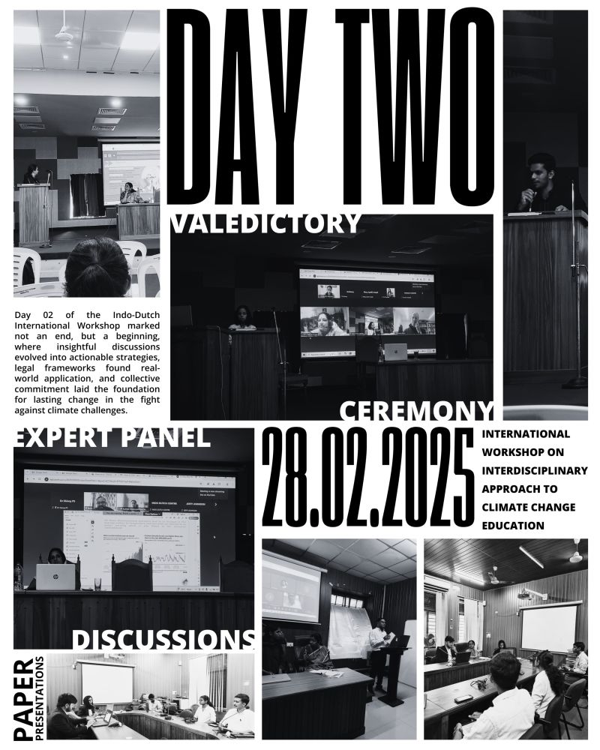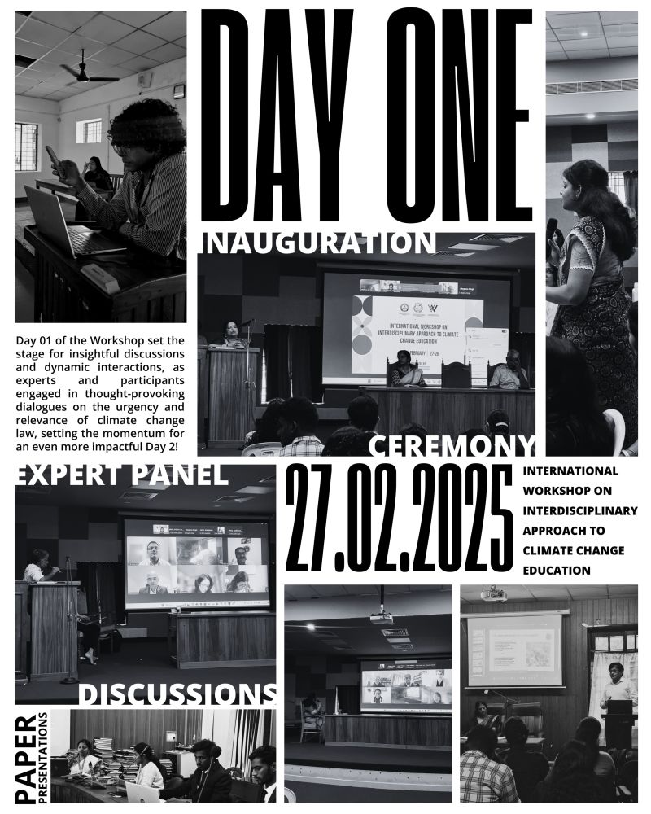

Publication following the workshop
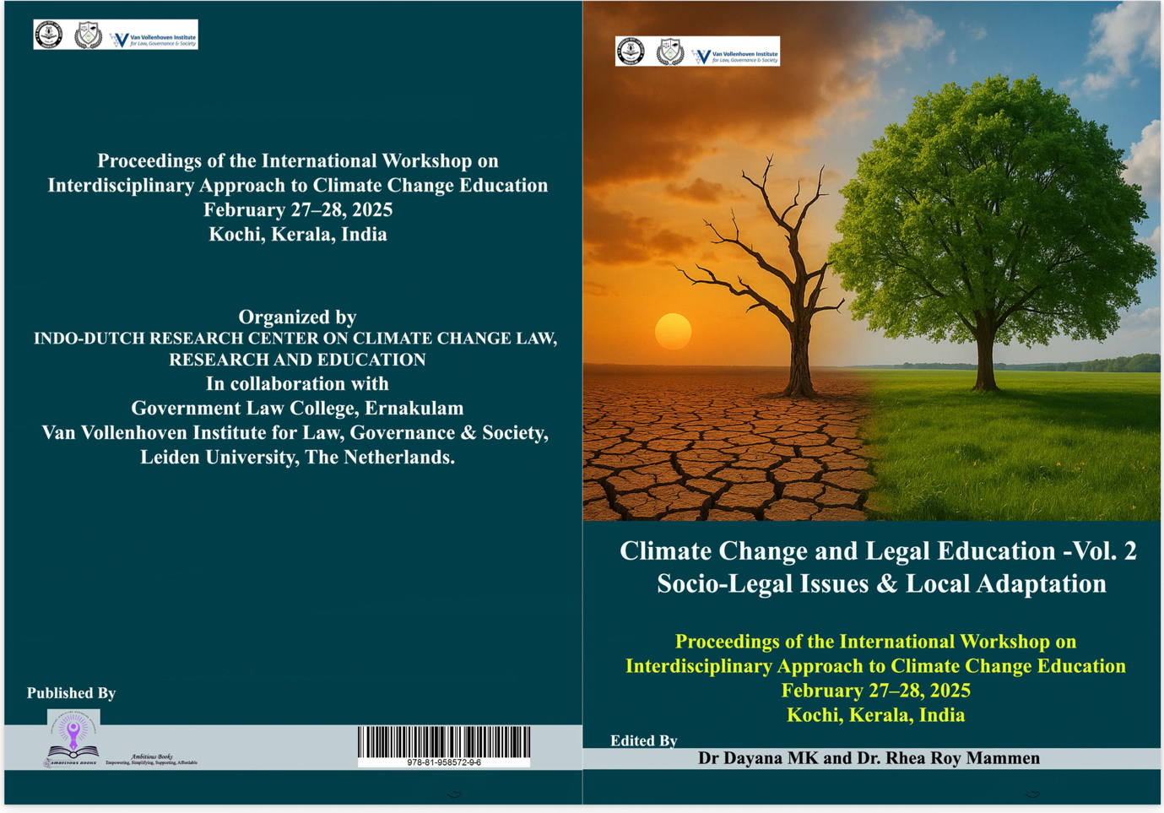

3. Publication Agreement with Springer Nature
We have obtained a publication agreement with Springer Nature for the book “Climate Conscious Legal Education”, giving faculty access to practical methods they can implement in class.
4. Faculty Development Programme

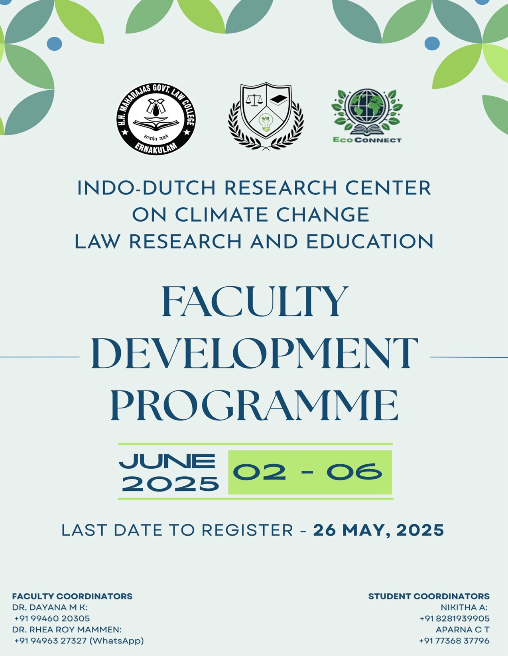

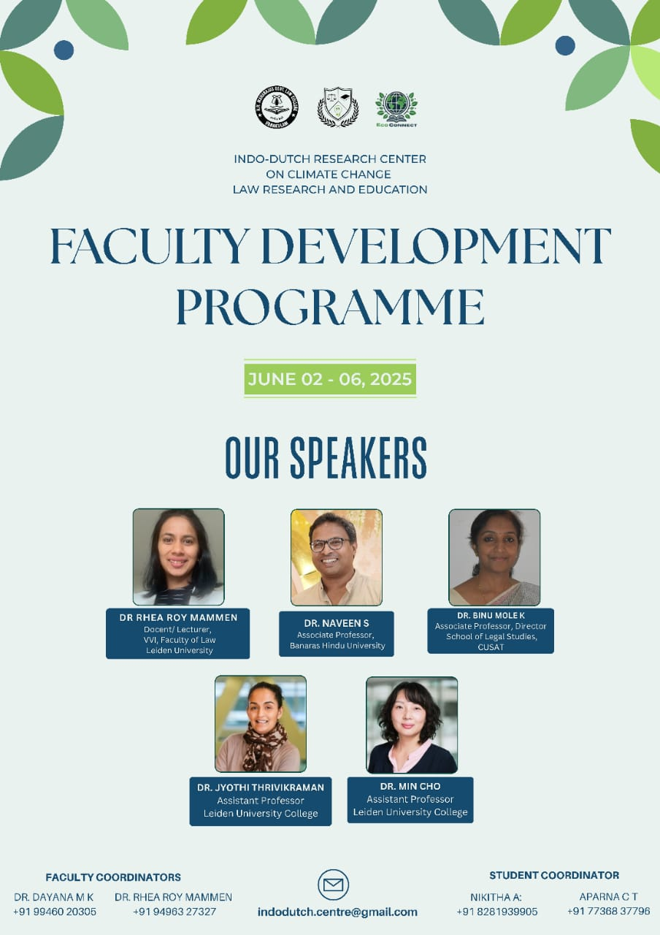

The week-long Faculty Development Programme (FDP) was co-organised by the Indo-Dutch Research Centre on Climate Change Law Research and Education in collaboration with EcoConnect, Leiden University College. The five-day programme focused on hands-on training for law faculty, enabling them to evaluate their current pedagogical practices and explore how classrooms can be transformed into spaces for critical dialogue and interdisciplinary engagement.

Structure of the Programme:
Day 1: Dr. Rhea Roy Mammen, Lecturer, Leiden University
The session introduced various approaches to integrating climate change into legal education, with discipline-specific examples. Emphasis was placed on brainstorming ways to tailor integration strategies, especially considering the limitations posed by the lack of autonomy in many affiliated colleges in India. The session provided a roadmap for the week’s activities and clarified the expectations for participants. Reading materials, particularly from the Climate-Conscious Lawyering project, were shared for discussion.
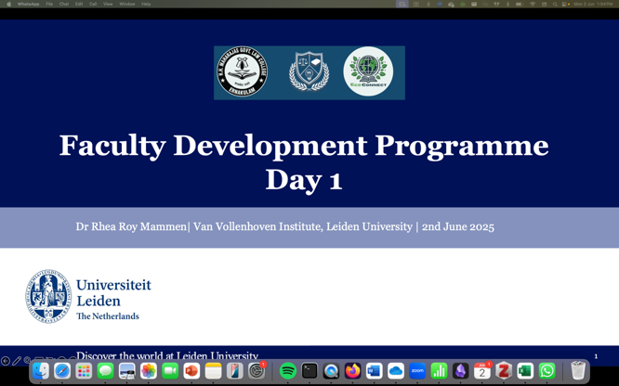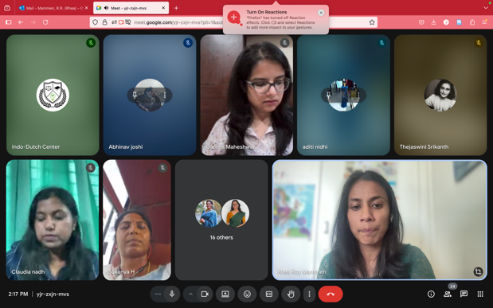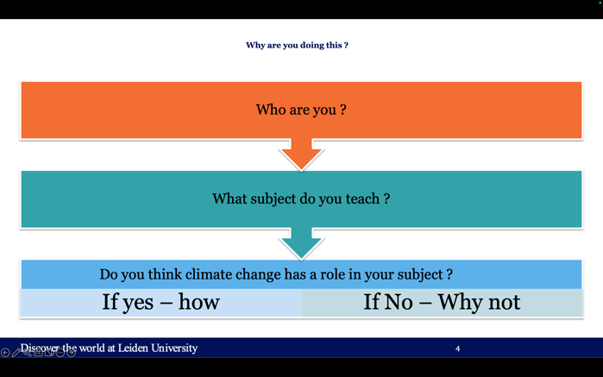
Day 2 & Day 3: Dr. Naveen S. and Dr. Binumol — Theoretical Foundations
These sessions focused on integrating climate change within public and private law frameworks. Dr. Naveen S., Associate Professor at BHU, and Dr. Binumol, Director at SLS, led lectures exploring climate change within national and international legal frameworks. They illustrated how climate concerns intersect with disciplines such as constitutional law, administrative law, torts, and corporate law. Participants were encouraged to reimagine their subject areas through a climate-conscious lens.
The emphasis throughout was not on radical curricular overhaul but on incremental changes—such as revising modules, adapting pedagogical methods, and incorporating case studies and simulations relevant to climate change within their existing disciplines.

Day 4 & Day 5: Dr. Jyothi Thrivikraman, Dr. Min Cho, Dr. Joeri Reinders (Assistant Professor), and Ms. Eve Aluna — Hands-On Sessions
Led by a team from Leiden University College (EcoConnect)—Dr. Jyothi Thrivikraman, Dr. Min Cho, Dr. Joeri Reinders (Assistant Professors of LUC), and Ms. Eve—the final two days were entirely interactive. Faculty members engaged with two overarching thematic questions, supported by structured templates to guide their reflection. Breakout sessions facilitated group discussions, allowing participants to share insights and explore the emotional dimension of teaching climate topics, including the concept of climate anxiety.
The programme concluded with a discussion of individual faculty assignments, where each participant proposed ways to incorporate climate change into their respective disciplines.
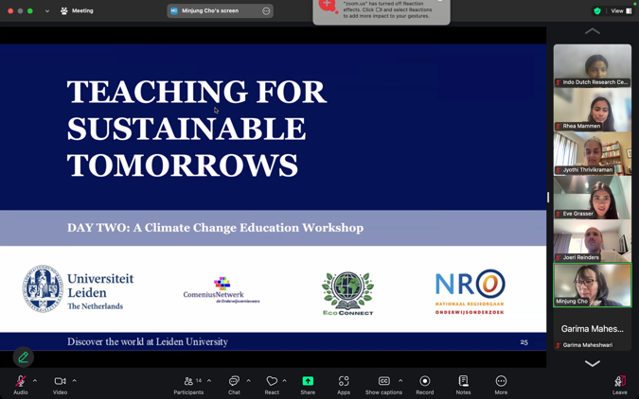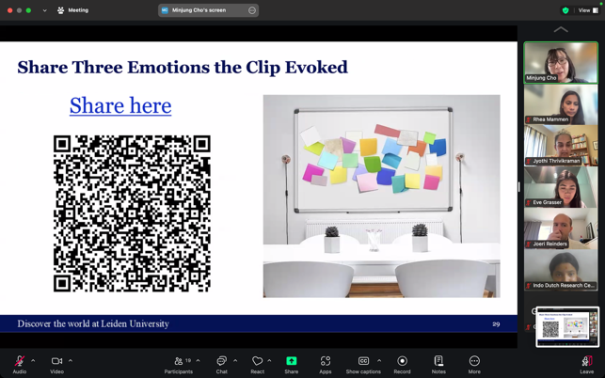

Outcome:
The FDP successfully encouraged participants to reflect on their pedagogical approaches and consider practical methodologies for integrating climate change law into their teaching. Sample contributions from the faculty are attached for reference.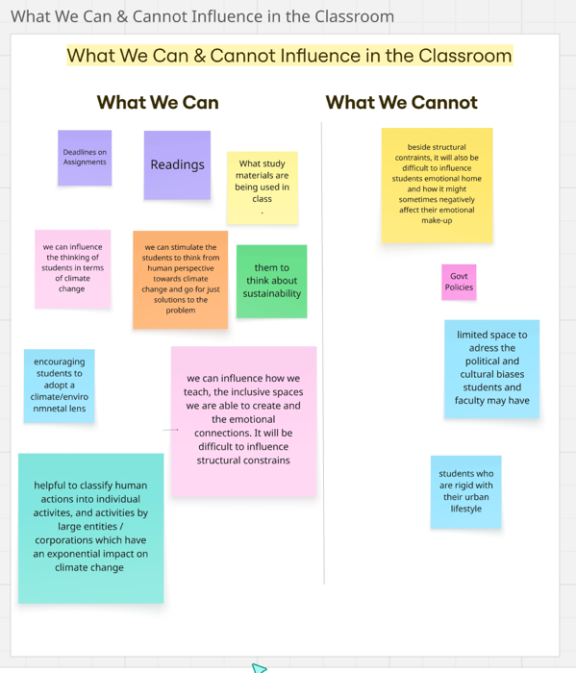

Future projects!
The MoU has been extended for further collaborative works.

